**Humanist Haggadah**

April 7, 2020

*This is a living document that should be updated by whomever is interested in augmenting the Passover experience to be more inclusive, educational and fun.*

Passover is set aside as a time to commemorate the exodus of the Jewish people from Egyptian slavery around 3000 years ago. The Jews lived in Egypt in peace for some time until a new pharaoh came to power and decided to oppress the Jews as labourers. This continued for 400 years until the Jews liberated themselves. The story goes that god helped the Jews escape by killing first-born sons, unleashing 9 other plagues on the Egyptians, and then parting the Red Sea so the Jews could escape and then restoring the Sea so it drowned the pursuing Egyptians.

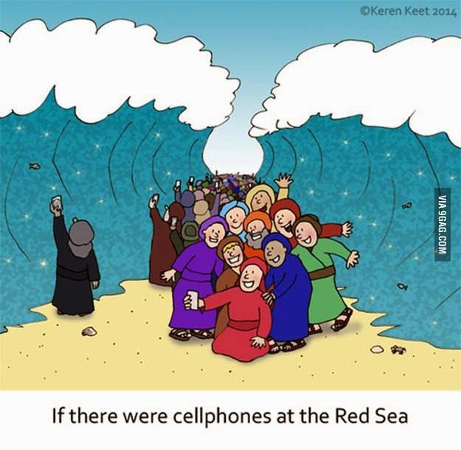

Being Jewish does not mean you need to believe this story. Being Jewish also doesn’t mean you need to believe that there is a god.

The Jewish people are called the chosen people. Many Jews believe this is because they were chosen by god. It is silly to think that Jews are any more special than anyone else. All people are equal and all are special. It is also silly to think that people are more important than animals, plants or any other form of life, since they all need each other to survive. And tonight, while Passover traditionally celebrates the freedom of Jews by god, we will actually be celebrating the freedom of life. All life needs to be free to live as it is intended to live, and we will discuss this tonight.

I believe that Jews are the choosing people, not the chosen people. Jews are free to choose whatever they want to believe and be whatever they like to be, and they still remain Jews. And people who choose to identify as Jews will also be called Jews because it is not an exclusive club. Things that exclude others only lead to hatred and bigotry and my form of Judaism is inclusive of everyone who wants to be included regardless of race, gender, sexual orientation, ability, beliefs, etc.

Jewish heritage can be traced back about 2000 years, which is a pretty cool thing. Abraham (the father of monotheism, lived around 1800 BC) had a son Isaac (at age 100!) who had a son Jacob. Jacob was a prolific dude and with 4 women fathered 12 sons who formed and led the 12 tribes of Israel. These tribes are recognized by Christians and Muslims too. The tribes fought many, many battles, including with each other, and 10 were wiped out. There was lots of drama among and within the tribes, proving humans have always been imperfect.

We are here today. This is the most remarkable and precious thing. The acts of the past have enabled us to be here today. But we are not just a product of human action. We originate from the original building blocks of the universe. We are made up of exactly the same matter that was part of the big bang 15 billion years ago. We are the product of many millions of years of evolution, adaptation and survival. We have breathed in plants, lived in rocks, cared for animals. We have adapted and survived through aquatic life, an ice age, famine, plagues, wars and viruses. We have been banged around, beat up, chased, made fun of, and harassed… And every time, mankind has picked itself up and risen to new heights. We have made steps backwards, sometimes big ones, but mankind is adaptive and resilient and through this change and challenge we only grow new skills and develop new ways to succeed in all circumstances. So tonight we celebrate resilience, adaptability and growth, and appreciate circumstances that are challenging enough to foster this growth.

It seems counterintuitive to celebrate difficulty and pain. Aren’t we supposed to pursue happiness and comfort? Those things feel good in a moment but they don’t give us the kind of skills the Jews developed 2000 years ago.

The Jews were living an agrarian lifestyle in Egypt, socializing, raising families, having discussions. Very comfortable. When they were enslaved, they still remained in their homes with their families. Their lives changed when they were forced to build the Egyptian pyramids under threat of pain. Oppression is an unfortunate situation and is something that is present even today. While the Jews had some of their freedom taken, they learned new skills in building. They built up their physical strength immensely and found new secretive but creative ways to communicate and interact. At the time, this situation may have seemed intolerable. In retrospect we will see that the growth experienced by the Jews is what enabled the creation and survival of Israel through some very difficult times.

Because these events took place 2000 years ago, and most people were not literate, and books did not exist, we don’t know any details of what actually happened. It likely was a tale made up as a bedtime story for some lucky kids. Never in our lifetimes have we seen frogs raining from the sky, water turning to blood or dust turning into lice. Science simply doesn’t allow these things to happen. We have seen pestilence of livestock and swarms of locusts, but not ones that happened from waves of a stick. So, in the absence of historical facts, we take the time to discuss the type of circumstances that would motivate people to seek change.

The Jews were said to be oppressed by the Egyptians. From Wikipedia:

*“Oppression is a form of injustice that occurs when one social group is subordinated while another is privileged, and oppression is maintained by a variety of different mechanisms including social norms, stereotypes and institutional rules. A key feature of oppression is that it is perpetrated by and affects social groups. ... [Oppression] occurs when a particular social group is unjustly subordinated, and where that subordination is* ***not necessarily deliberate*** *but instead results from a complex network of* ***social restrictions****, ranging from* ***laws and institutions to implicit biases and stereotypes****. In such cases, there may be no deliberate attempt to subordinate the relevant group, but the group is nonetheless unjustly subordinated by this network of social constraints.”*

Slavery has existed since civilization began. For 10,000 years people have stolen lives that they felt were inferior to be used for forced labour, sexual gratification, entertainment and war. People were treated as property, bought and sold, beaten, raped and killed. In the early 1800s some countries started to outlaw slavery. It was abolished in the US in 1861 – slavery was so important to the southern US that they fought a civil war to keep it!

Thinking back to oppression, forms of oppression today may not be so obvious. “What forms of oppression do you see?”

[discuss with group]

Even within the Jewish community we can observe several forms of oppression:

* Superiority of men over women
* Exclusion of non-Jews and Jews who don’t follow the ‘rules’
* Self-loathing and inferiority to a higher power
* Superiority over other people as the ‘chosen people’
* Stereotypes of ourselves
* Intolerance for new interpretations and beliefs with Judaism

There are countless forms of oppression, and in each case we need to support and assist in the struggle to rid the world of oppression. And remember that oppression is not just about people. People are only one inhabitant of the earth, and oppression applies to all living creatures that need to be free to live an authentic life free of suffering.

We even oppress ourselves! We develop a voice in our head that speaks to us all the time. It tells us how we are not good enough, how others are different and inferior, how it’s okay to exclude and mistreat people, how it’s okay to allow other things to suffer. We need to stand up to this voice as strongly as we need to stand up to external forms of oppression so that we can be the person we really are.

So, we will use this occasion to think about the ancient past and talk about what became of that. We will talk about the present and the opportunities that exist, and we will talk about the future and the world we’d like to create. We have free will and internal forces that guide us, and we will use this time to explore how to best channel that potential.

We will not discuss the story of the Pharaoh and Moses and the 10 plagues and how god killed every firstborn son in homes that didn’t have lamb’s blood painted on the door. We have heard this tale before and it is pretty sensational and gruesome.

People have been mistreated in the past, and this is unfortunate. Some people have lived an entire life knowing only suffering, oppression and hardship. The Holocaust took place over years and many people died after suffering immeasurably for 3 or 5 years. And the psychological toll would have been felt long after the people were liberated.

In nature we often see things that seem uncomfortable and unpleasant, but because of our perspective we know that these things are not unpleasant in the longer term and in fact provide great growth from the challenge.

A pregnant woman has more difficulty moving around, but after 9 months she delivers something that she (hopefully) enjoys for many years. A caterpillar goes into a cocoon that seems like a coffin but emerges a butterfly and now can soar in the skies. Trees lose all their leaves in autumn, which may look very sad at a glance, but this shedding is to allow stronger growth in the spring. So, what appears to be suffering may indeed by suffering, but within all challenging situations there is opportunity for growth.

*Can you name any situations that were uncomfortable or challenging but resulted in something good?*

As we discussed, the Jews were forced to build temples and pyramids. Their bodies became strong and they became unified toward one common enemy. So later when they left Egypt for Israel, the Jewish people were knowledgeable, strong and determined. It is said that they wandered for 40 years. The distance was roughly 1000 km from Goshen (Cairo) to Israel (Canaan), and walking 10km per day is quite doable, so it probably didn’t take 40 years to do a journey that could be done in 3 months. It is also said that the Jews didn’t have time to let their bread rise while fleeing in the desert, but if they averaged only 200m every day (which you can run in about 30 seconds), they were clearly not in a hurry and perhaps just liked eating big crackers. We are also made to think that the Jews had inadequate sustenance. We know that bodies cannot survive without water, protein and fat. Making matzo requires water. Protein comes mostly from animals, but also comes from beans, tofu, eggs and other things, and this all suggests they weren’t in the desert very long. In fact, matzo is made from flour and flour comes from wheat. Growing and harvesting wheat takes a long time and cannot be done in a desert. So, the story is quite imaginative!

The Jews arrived in Israel eventually. The land was fertile and lush, but it was also occupied by Canaanites. The Hebrews, as they were called, fought for years with the Canaanites and then the Philistines, and lost often. It took a long time for them to take over the area, and even then it was taken by others over 20 times. Large loss of life, destroyed temples, displaced populations. It was more than 1500 years of fighting until Israel was formed in 1948, and even then it’s been attacked regularly including being attacked by 6 countries at the same time in 1967. That’s a lot of suffering!

We are going to take a moment of reflection now to consider all the suffering of the past. Slavery, wars, famine, oppression, suffering, political prisoners, dissenters, supposed witches, victims of genocide, harassment, bullies and authoritarians. This includes animals who have lived in factory farms and zoos, flowers that were plucked from their stems, and trees that were cut down for a better view. At the same time we are going to think about our own ancestors. The many, many people who came before you. People who had hopes and dreams, took chances, faced and overcame challenges. We honour them for their sacrifices for their future families, for their contributions and for all that they did to allow us to be here today.

In Jewish tradition, we are going to use some symbolism. We are going to eat something bitter to represent all of the bitter things of the past. And then we are going to drink a glass of wine to celebrate the triumph of life and spirit that has manifested in us all.

But you need to earn your bitterness and beverage by correctly answering 2 questions:

[ask questions]

[eat pickles/radish/etc, drink wine/beverage]

Thinking back to a situation where Jews had homes and families and forced labour under whip, they “escaped” only to live out many years of fighting, torture, death and displacement, including amongst themselves. Not much of this seems celebratory.

For me, the lesson that I keep alluding to is growth. The only way we grow in meaningful ways is to be challenged. Some things are horrific and we don’t seek this kind of challenge, but manageable challenges force us to learn new knowledge, new skills, new approaches. It is said, “whatever doesn’t kill us makes us stronger.”

Charles Darwin, the father of evolution, taught us that the creatures that survive are not the strongest nor the fastest nor even the smartest. The creatures that survive are the ones most adaptable to change.

Whatever conditions were real for the Hebrews gave them greater resilience, greater strength and greater knowhow. And they used this to build homes and buildings, and created systems of law and justice, and developed military expertise and might. None of this would have been available had they not endured a period of challenge. In fact, the Jewish people are considered to be among the most successful, and the reason most likely is that they have been faced with so many challenging circumstances. Slavery, wars, bigotry, pogroms, hatred, oppression. The Jews were the primary target of the Holocaust and despite Germany’s military might, the Jews found ways to survive, even defenseless in ghettoes. Nowadays Jewish people pride themselves on prioritizing education, family relations and being charitable.

Jews represent only 0.2% of the global population. Just 16M Jews in 8B people. Yet Jews have been awarded 206 out of 900 Nobel prizes[1]. That’s 23%!! There is little doubt from this statistic alone that the Jews have developed some formidable skills which include thinking in ways nobody has ever thought before – a great adaptation! I believe that all humans are capable of achieving the same achievements. Writing great music, building great buildings, inventing great inventions. We honour animals and plants less for not doing the same, but tweet great songs, build great nests and use tools as we use tools. Challenge allows us to achieve our greatest potential.

Creatures need struggle but not oppression. Creatures need challenge but not cruelty. To be able to capitalize on opportunities, creatures need some basic things in place. We need clean air, food and shelter so that we don’t only feel hunger. We need freedom, hygiene and safety so we aren’t always fearing for our lives or living trapped. And we need these things to be sustained so that we can focus on other things.

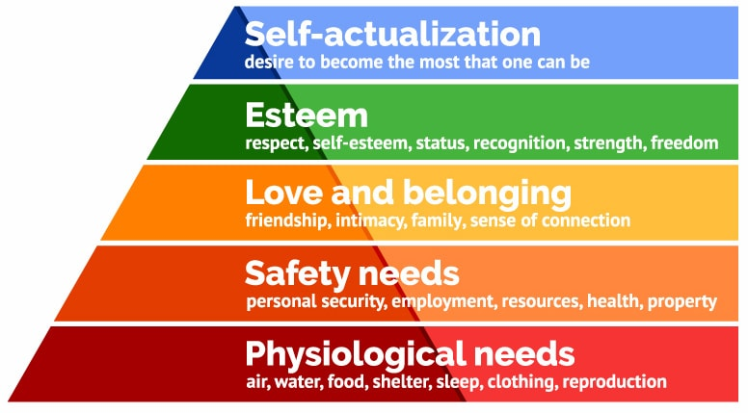

Where we are needed most is where creatures lack food, water, shelter, freedom and security. There is no reason why any creature should suffer, and it is an obligation to assist where there is suffering. Even animals try to nurture us when we are sick or hurt, and we have this same instinct.

Time again for some symbolism. For adaptability we only need to look to the humble cucumber. It originated in India and its seeds have been traced back to 9750 BC. It can grow just about any place on earth. It’s been grown in space and 1 mile underground in a nickel mine. It’s 96% water but is quite solid. It produces male and female flowers and offers pollen to bees. We can now earn a piece of cuke (or pickled cuke) to symbolize the kind of adaptability and resilience that encourages continuity. You need to answer two questions correctly:

[ask questions]

For helping in struggle and seeking peace we are going to say some Hebrew words from a song:



Now we toast to our responsibility for peace.

[ask question]

[drink wine/beverage]

Character is described as what you do when nobody is looking. Within all of us is the ability to be our best or worst selves, and everything in between. Starting with our own positive self-talk and self-care we are capable of achieving our best selves. Removing judgement and acting with compassion and acceptance. Showing your vulnerability and kindness and not allowing others or circumstances to change the person you are and the ways that you act. Remember that the worst people started as innocent children who allowed their fears and subsequent hatred to consume them.

The world is whatever we choose to make of it and we can choose a future that honours life and freedom. Letting everyone and everything be what they are. Living a life that makes your ancestors proud and their sacrifices meaningful. This all starts with character and your ability to be the captain of your own ship.

Look around the room and really see who is there and think about the following questions:

[past]

What sacrifices and struggles allowed this person to be here today? How amazing is this person such that the universe donated its precious atoms to make them? What do they carry in them from 2000 years of lineage? Do you appreciate the statistical impossibility of their existence today?

[present]

What soul is contained within this person? To what does this person’s soul resonate? How are you connected with this person? What struggles have enabled this person to achieve new heights?

[future]

How can you better empower this person to authenticity and free will? What struggles lie ahead for this person that could be celebrated and enjoyed?

We conclude the Seder by asking people if they have anything to share about their own growth or learnings from the past year. We want to update our Haggadah every year with new wisdom so that we can remember and pass on the best of us.

Once done, everyone is welcome to dance the Hava Nagila (“let us rejoice”)

<https://www.youtube.com/watch?v=X8N4TiRLpXg> (Harry Belfonte with English subtitles)

**My Passover Tale**

*Reinvent the story of the Jews in Egypt*

A new Pharaoh in Egypt came to power. He decided that the Jews should

his . The Jews were very by this

edict and immediately wanted to some . They

a few

and then to the

. The Pharaoh didn’t even notice how Moses his

. It was massive!

The Pharaoh wasn’t happy and his

. It was time to see Moses in person.

The Pharaoh found Moses in the . He said, Moses, you are such a

. Moses took a moment and said, “that may be true

Pharaoh, but there’s something I need to say”. “ my

!!!”

grab/grabbed dance/danced huge excited upset

touch/touched muscles clenched

1. <https://blogs.timesofisrael.com/after-206-nobel-prizes-its-time-for-the-big-question/>